Homework for the 3-D QSAR : SIOW JIA SHENG

Introduction
We have used QSAR (Quantitative structure-activity relationship) as computational mathematical methods to build models that show us the statistical significance of correlations between a series of molecular structure are their associated biological property. The usual 2D QSAR method, have limitations only one or two dimensions to describe the structure. Therefore, we use 3-D QSAR to view their spatial arrangement and graphical outputs that provides us more accurate potential drug-receptor interactions.
A dataset named DAT, which has been chosen to analyze in this article. The dataset has 36 training molecules and 6 test molecules, which is less than the maximum value the of number of molecules we can upload into the web portal. This dataset is one of the 30 publicly available datasets that that were used to assess the Py-CoMFA application and robustness. The datasets are all pre-aligned with their associated bioactivities were retrieved from the literature. The analysis and QSAR model building are done through the www.3d-qsar.com web applications suites portal.
This dataset chosen represents dopamine transporter (DAT), which suggest the key site of action for drugs, such as cocaine in the central nervous system. The findings from the QSAR model provide us the guide for the design of the improvement of compounds with DAT activity, that is important to treat cocaine addiction and some neurological disorders.

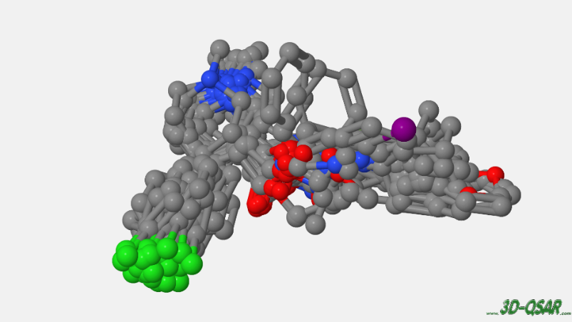
Figure 1: Superimposed molecules of DAT.
Diagram shows the overlap of all molecules in the dataset. This is the DAT alignment rule, the molecules are aligned based on the scaffold.

Methodology
- The chosen dataset is: “15.DAT” data set, and 36 training set and 6 training set are selected to make 3D-QSAR model in the 3D-QSAR.com web application. The test set will prove the external predictivity of the resulting model. The unit for activity used is pKi.
- The molecules are first submitted to make 3D QSAR model, with default model used by Cramer in original CoMFA, to compare the values obtained later.
- Then the CV is set to “true” to compare the result with the previous one. This means that the model’s robustness was evaluated by the means of cross validation using leave-one-out method (LOO).
- The dataset is calculated throught VPO calculation, and submitted 10 times to have 100 combinations of parameters to get the best result. This vary all the pre-treatment settings such as method TRIPOS, Autogrid, O3G, EasyMIF, and different charge model, etc. Random combinations were run until no substantial increment of q² value was reached.
- The results are rearranged with the best Combined CV score, and the selected result with highest score will then generate the maps.
- We repeated the above steps with original parameters, then with run through VPO, and run with Y scrambling, and with Y-scrambling and validate with external test set. Y-scrambling is set to true and is run through 10 iterations. More iterations (100 iterations) would give more promising results, but the time taken is too long and not feasible.
- The values and maps are inspected. The results are in the attachment.

Statistical coefficients obtained from the calculation

General dataset
A model with high value of score (higher than 0.7) is considered a good model. For this qsar model after running through iterations and calculations with different combination, Since the most informative model is the COMBINED one, we arranged the 100 models with the highest score of COMBINED values, and generate the map. We get a high score of 0.744 for q² Combined CV score. Therefore we selected this model to generate the map and further analyse.
The datset used is the DAT, where it has 36 training molecules and 6 test set molecules. Among these molecules, we can see that the maximum potency obtained is 7.81, and the minimum potency is the 3.76, so that the activity range is 4. The structure of the molecules with the highest potency is below, it has pAct value of 7.81, the molecule name is 2g. (SMILES: CN(C)C(C[C@H]1C[N@@H+](C)CC[C@@H]1c1ccc(cc1)[Cl])=O )
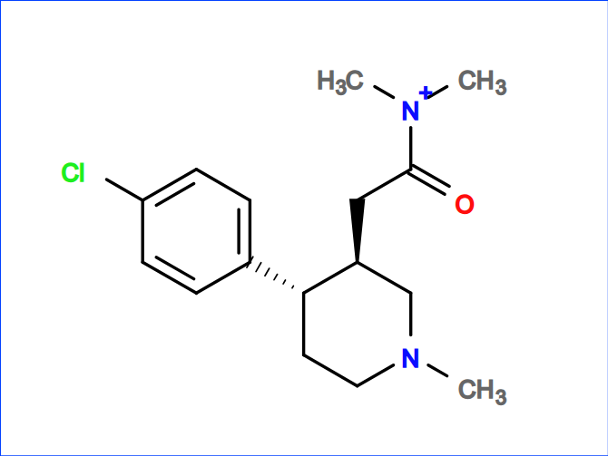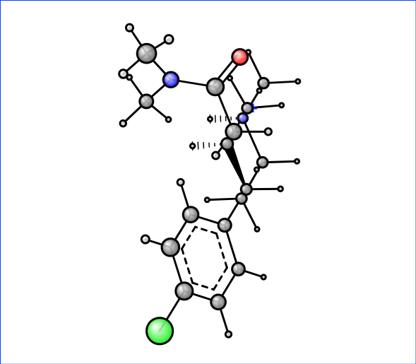
Figure 2: Hghest potency Molecule 2g - 2D and 3D structure
Meanwhile, the structure of the molecule with the lowest potency is below, it has pAct value of 3,76, the molecule name is 1a. (SMILES: C[N@H+]1CC[C@H](c2ccc(cc2)[Cl])[C@H](C1)C([O-])=O)
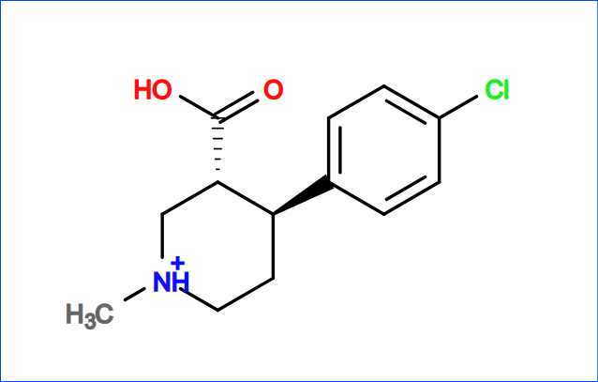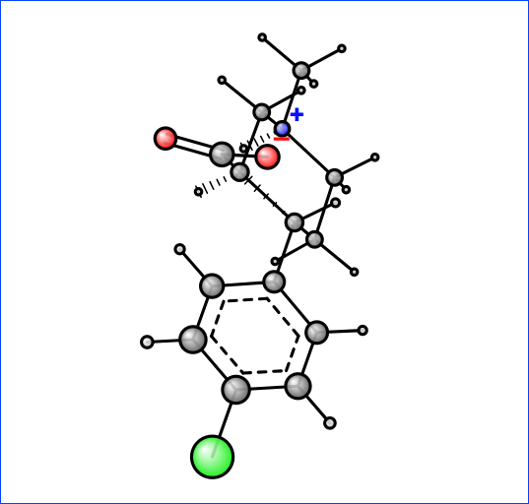
Figure 3: Lowest potency moelcule 1a- 2D and 3D structure

Interpretation
We evaluate the statistical coefficients through several following parameters:
- R2 : the squared correlation coefficient, The value of r2 is 0 ≤ r² ≤ 1.
$$r^{2}=1- \frac{\sum_{i=1}^{N}{{(Y_{exp,i}-Y_{calc,i})}^{2}}}{\sum_{i=1}^{N}{{(Y_{exp,i}- Ȳ)}^{2}}}$$

- SDEC: standard deviation error in calculation.
- q²_{cv} : the cross validated r². The value of q² is -∞ ≤ q² ≤ 1. This is used as a criterion for both robustness and predictive ability of the model.
$$q^{2}=1- \frac{\sum_{i=1}^{N}{{(Y_{exp,i}-Y_{pred,i})}^{2}}}{\sum_{i=1}^{N}{{(Y_{exp,i}- Ȳ)}^{2}}}$$

- SDEP CV : Standard Deviation Error of Prediction, cross validated q², where N is the number of predicted compounds. The best result is as low as possible, approaching 0.
$$SDEP= \sqrt{\frac{\sum_{i=1}^{N}{{(Y_{exp,i}-Y_{pred,i})}^{2}}}{N}}$$

Therefore, we want the result that results the highest r² and q² approaching 1, and with SDEP approaching 0. The cross validation set used in our models is LOO (leave-one-out) cross validation. This means that we split the dataset into training and testing set, but only use one observation as part of the training set. After we build the model out of training set, the model is used to predict the response value of the one observation left out of model.

Results and Discussion
We can compare the values before and after optimized the best model we get though VPO, we arranged the best score with best COMBINED q² CV:
 | Initial (without VPO and default settings) | Optimized VPO (without Y scrambling) | Optimized VPO (with Y-scrambling) | Optimized VPO with Y-scrambling and external test set
Number of training compounds | 36 | 36 | 36 | 36
Number of test compounds | 6 | 6 | 6 | 6
Method | TRIPOS | O3G | O3G | O3G
q² cv combined | 0.569 | 0.733 | 0.726 | 0.744
r² combined | 0.919 | 0.984 | 0.981 | 0.996
Combined CV score | 0.713 | 0.822 | 0.817 | 0.829
Probe | C.3 | C.3.H2 | C.3.H1 | CI
Charge model | gasteiger | eem | eem | eem2015ha
Table 1: 3D-QSAR model result for different settings.
The above best result ( Optimized VPO with Y-scrambling and external test set) setting were obtained with minimum sigma 0.900, grid space 1.700 Å, grid extension 9.000 Å, and cutoff energy of 16.000 kcal/mol.
The method are same for 3 best results, but the q²_{cv} value lowers a bit when we compare without and with Y-scrambling. This is expected because we are using Y-scrambling in the calculation, and r²_{ys} < r² and q²_{ys} < q². Scrambling helps find biases, overfitting and make fair comparison between model, and verify lack of correlation. This is a statistical test of prediction tool, that the model are fitted to randomly reordered property or activity values, and compared with the model obtained for the actual property or activity values. We use this to know the model prediction are not made by chance. We will expect that the model performs well on the original data, and poorly on the shuffled data. The good Y-scrambling values are being 50 to 100 iterations. But due to limited resources on the portal and time constraints, 100 iterations are not feasible. In this investigation, the Y-scrambling here are set to 10 permutations, and used few days to calculate. The presence of Y-scrambling gives a more reliable and accurate for model.
Then we run the model with test set, we get even better result. We further inspect the best model, which is with Y-scrambling and external test set. The following result is the COMBINED result, because it is the most important to inspect, and the statistical values and contour map we inspecting is the PC7, which is the most optimal result.

PC | r² | SDEC | q²_{cv} | SDEP_{cv} | q²_{ext} | SDEP_{ext} | r² YS | SDEC YS | q² _{YS} | SDEP YS
1 | 0.475 | 0.579 | 0.23 | 0.701 | 0.459 | 0.291 | 0.304 | 0.667 | -0.089 | 0.834
2 | 0.893 | 0.262 | 0.488 | 0.572 | 0.473 | 0.287 | 0.575 | 0.521 | -0.022 | 0.808
3 | 0.952 | 0.175 | 0.676 | 0.455 | 0.16 | 0.362 | 0.811 | 0.348 | 0.062 | 0.774
4 | 0.97 | 0.137 | 0.699 | 0.438 | 0.182 | 0.358 | 0.889 | 0.266 | -0.109 | 0.842
5 | 0.983 | 0.103 | 0.724 | 0.42 | 0.249 | 0.342 | 0.958 | 0.163 | 0.071 | 0.77
6 | 0.992 | 0.072 | 0.732 | 0.413 | 0.377 | 0.312 | 0.967 | 0.145 | -0.238 | 0.889
7* | 0.996 | 0.051 | 0.744 | 0.405 | 0.497 | 0.28 | 0.996 | 0.048 | 0.11 | 0.754
8 | 0.998 | 0.037 | 0.746 | 0.403 | 0.539 | 0.268 | 0.994 | 0.06 | 0.067 | 0.772
* = optimal PC
Table 2: Statistical result for DAT dataset model (COMBINED model field)

From the result above, we can see that the PC8 has the highest value of both r² and the q² CV value, and SDEC value is the lowest. The model also gives us the optimal PC combined is 7, which is good enough and close to the PC8. From the data in table above, we can also obtain its plot as below to better visualize.

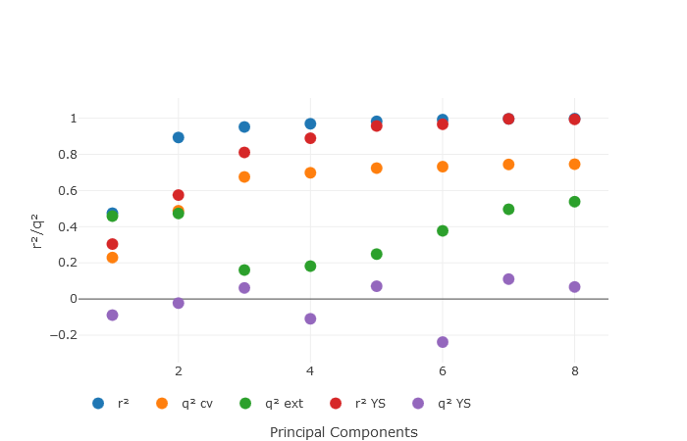
Figure 4: dependence of the r2/q2 values with the principle components.

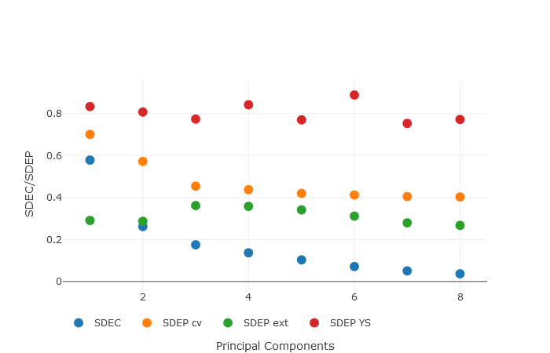
Figure 5: Dependence of the SDEC / SDEP values with the principle components.

Exp /Recalcd / Pred Activities
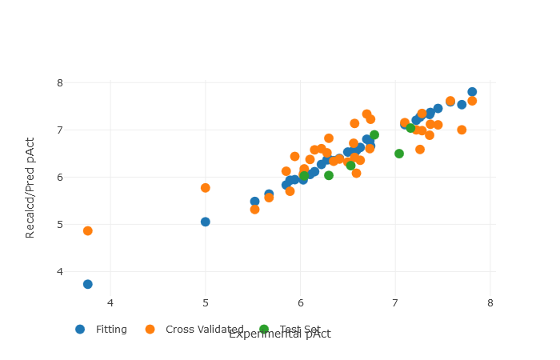
Figure 6: Recalculated and predicted versus the experimental activities
This is the plot, comparing the experimental potencies, with those recalculated / predicted by the model. The data is from the PC7. The values are in the table below, arranged by the number: We can see that the molecule highlighted in yellow, which has the lowest activity, while the molecule highlighted in green has the highest activity.
 | ID | Name | Exp | Fit/Pred | Err Fit/Pred | CV | Err CV | Mol Set
1 | 1775937 | 1a | 3.76 | 3.731 | 0.029 | 4.861 | -1.101 | Training Set
2 | 1775938 | 1b | 6.63 | 6.631 | -0.001 | 6.36 | 0.27 | Training Set
3 | 1775939 | 1c | 6.28 | 6.367 | -0.087 | 6.514 | -0.234 | Training Set
4 | 1775940 | 1d | 6.5 | 6.531 | -0.031 | 6.321 | 0.179 | Training Set
5 | 1775941 | 1f | 5.94 | 5.947 | -0.007 | 6.437 | -0.497 | Training Set
6 | 1775942 | 1g | 5.85 | 5.834 | 0.016 | 6.125 | -0.275 | Training Set
7 | 1775943 | 1h | 7.28 | 7.324 | -0.044 | 6.984 | 0.296 | Training Set
8 | 1775944 | 1i | 5 | 5.051 | -0.051 | 5.774 | -0.774 | Training Set
9 | 1775945 | 1j | 5.67 | 5.643 | 0.027 | 5.564 | 0.106 | Training Set
10 | 1775946 | 1k | 6.04 | 6.104 | -0.064 | 6.177 | -0.137 | Training Set
11 | 1775947 | 1l | 6.73 | 6.768 | -0.038 | 6.603 | 0.127 | Training Set
12 | 1775948 | 1m | 6.41 | 6.394 | 0.016 | 6.385 | 0.025 | Training Set
13 | 1775949 | 1o | 6.3 | 6.375 | -0.075 | 6.825 | -0.525 | Training Set
14 | 1775950 | 1p | 7.22 | 7.207 | 0.013 | 7 | 0.22 | Training Set
15 | 1775951 | 1q | 6.1 | 6.057 | 0.043 | 6.375 | -0.275 | Training Set
16 | 1775952 | 1s | 6.59 | 6.564 | 0.026 | 6.081 | 0.509 | Training Set
17 | 1775953 | 1t | 6.22 | 6.271 | -0.051 | 6.602 | -0.382 | Training Set
18 | 1775954 | 1u | 6.57 | 6.535 | 0.035 | 6.416 | 0.154 | Training Set
19 | 1775955 | 1v | 6.56 | 6.561 | -0.001 | 6.72 | -0.16 | Training Set
20 | 1775956 | 1w | 6.74 | 6.659 | 0.081 | 7.227 | -0.487 | Training Set
21 | 1775957 | 1y | 7.26 | 7.273 | -0.013 | 6.587 | 0.673 | Training Set
22 | 1775958 | 2a | 5.52 | 5.485 | 0.035 | 5.315 | 0.205 | Training Set
23 | 1775959 | 2b | 7.1 | 7.113 | -0.013 | 7.153 | -0.053 | Training Set
24 | 1775960 | 2c | 7.45 | 7.454 | -0.004 | 7.109 | 0.341 | Training Set
25 | 1775961 | 2d | 6.03 | 5.941 | 0.089 | 6.054 | -0.024 | Training Set
26 | 1775962 | 2e | 6.15 | 6.118 | 0.032 | 6.577 | -0.427 | Training Set
27 | 1775963 | 2f | 6.57 | 6.523 | 0.047 | 7.136 | -0.566 | Training Set
28 | 1775964 | 2g | 7.81 | 7.807 | 0.003 | 7.615 | 0.195 | Training Set
29 | 1775965 | 2i | 7.36 | 7.33 | 0.03 | 6.889 | 0.471 | Training Set
30 | 1775966 | 3a | 5.89 | 5.933 | -0.043 | 5.703 | 0.187 | Training Set
31 | 1775967 | 3c | 7.28 | 7.324 | -0.044 | 7.351 | -0.071 | Training Set
32 | 1775968 | 3d | 6.7 | 6.804 | -0.104 | 7.338 | -0.638 | Training Set
33 | 1775969 | 3e | 6.35 | 6.348 | 0.002 | 6.338 | 0.012 | Training Set
34 | 1775970 | 3f | 7.7 | 7.535 | 0.165 | 7.001 | 0.699 | Training Set
35 | 1775971 | 3g | 7.58 | 7.595 | -0.015 | 7.616 | -0.036 | Training Set
36 | 1775972 | 3h | 7.37 | 7.37 | 0 | 7.12 | 0.25 | Training Set
37 | 1775973 | Mol_1e | 6.04 | 6.028 | 0.012 |  |  | Test Set
38 | 1775974 | Mol_1n | 6.3 | 6.037 | 0.263 |  |  | Test Set
39 | 1775975 | Mol_1r | 6.53 | 6.245 | 0.285 |  |  | Test Set
40 | 1775976 | Mol_1x | 7.04 | 6.498 | 0.542 |  |  | Test Set
41 | 1775977 | Mol_2h | 6.78 | 6.895 | -0.115 |  |  | Test Set
42 | 1775978 | Mol_3b | 7.16 | 7.042 | 0.118 |  |  | Test Set
 | ID | Name | Exp | Fit/Pred | Err Fit/Pred | CV | Err CV | Mol Set
Table 3: DAT training and test set experimental and predicted activity by the final 3D-QSAR model.

Interpretation of the CoMFA maps

Dataset contour maps
In this map, we have four models to inspect, which are STE (steric), ELE (electrostatic), SUM(ELE + STE), and the COMBINED(ELE_STE). We will inspect the COMBINED one because it gives us most informative about the model.
We will investigate the most important contour, which is the one obtained by multiplying the PLS coefficient values, by the average MIF values. By looking at this, we can know how to modify the molecules, to increase the activity in the given space around them. Therefore, we can see the steric, electrostatic, hydrophobic, and hydrogen bond donor and acceptor fields from the contour maps.
The red area and blue area contour are the area for electrostatic interactions, and are mostly related to the ability of molecules to establish hydrogen bond (acceptor and donator). It is the attractive or repulsive interaction between charged molecules. The red shows the region of higher electron density, that with high binding affinity (negative charge), meanwhile the blue shows lower electron density, with less affinity of the compound to bind the protein (partial positive charge).
The green and yellow area are related to steric hindrance of the molecules. Steric hindrance is the slowing of chemical reactions, due to steric bulk, because the large group prevent chemical reactions. The Green area means we can increase the volume of the molecule, in the region overlapping. Yellow are means we have to decrease the volume to increase the potency of molecules.
We inspect the best model contour maps generated using the Coeff x Mean, to observe the steric and electrostatic ComFA like maps. The least and most active molecules are superimposed as shown below.
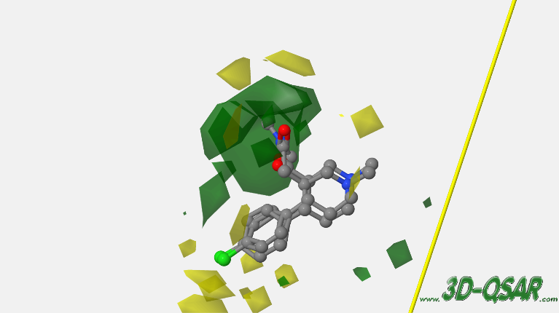
Figure 7：The contour map for the steric mean for superimposed molecules
Due to the presence of oxygen (red atom), there is a large region of green contour around the atom. The steric contour maps can give us information to increase (positive, green) or decrease (negative, yellow) in activity, based on the presence of certain steric hindrance.

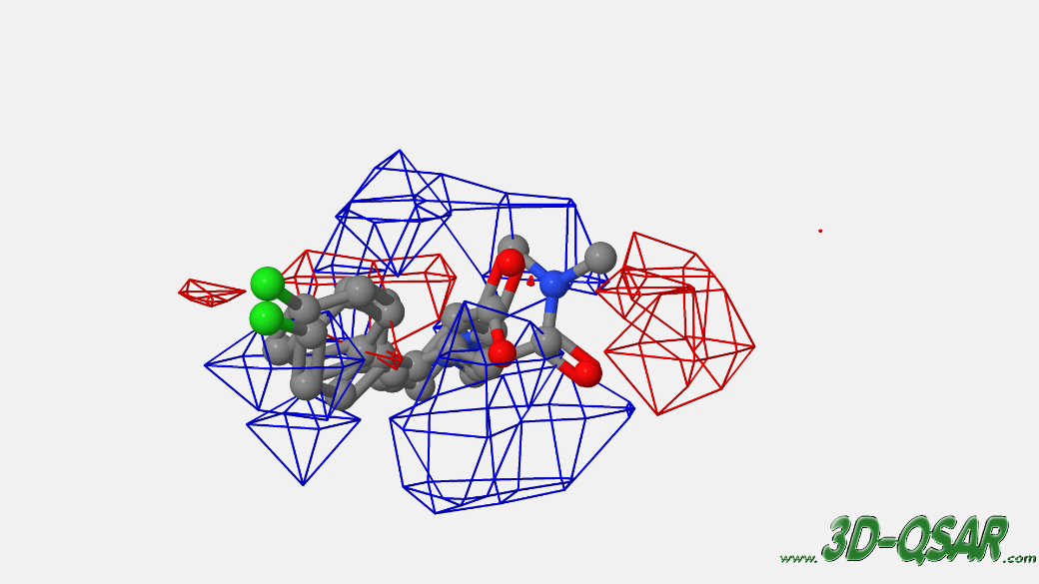
Figure 8: Electrostatic mean contour map for superimposed molecules
Near the chlorine atom (in light green) has red contour, can be hypothesised by the contribution to the molecules activity. The area around the structure of the molecules show blue contour, shows that activity might not happen in the area. This electrostatic contour maps give us information about molecules’ charge, to see whether the area is attractive or repulsive forces favoured. In positive electrostatic contour maps (blue) , the attractive forces are favoured, while the negative electrostatic contour maps (red) the repulsive forces are favoured.

Training Molecules Maps
Now, we can inspect the original MIF for each molecule, and also the transformed MIFS. We will inspect the most important MIF for each molecule, which are those obtained by the multiplication of the MIF value, by the PLS coefficient. This gives us the activity contribution maps, that explain to which part of the molecule the potency related to. We increase the value to 90 to see the maps. The parameters for training contour we viewed here are “ELE ACT_CONTR Positive”, “ELE ACT_CONTR Negative”, “STE_CONTR Positive”, “STE ACT_CONTR Negative”, that give us the activity contribution contour of that area.

We also compared the most potent molecule maps, with the least potent map. This is because of the activity is very different, the maps will be also very different. The more green means more potent, and more yellow means less potent. In green we see positive steric field, where it is encouraged to add substituent to increase activity, while in yellow we see negative steric fields, and further steric hindrance not recommended that could lead to less activity. Therefore, we can look at the maps for the highest and lowest activity are different, showing that which important parts that contributed to the activity.

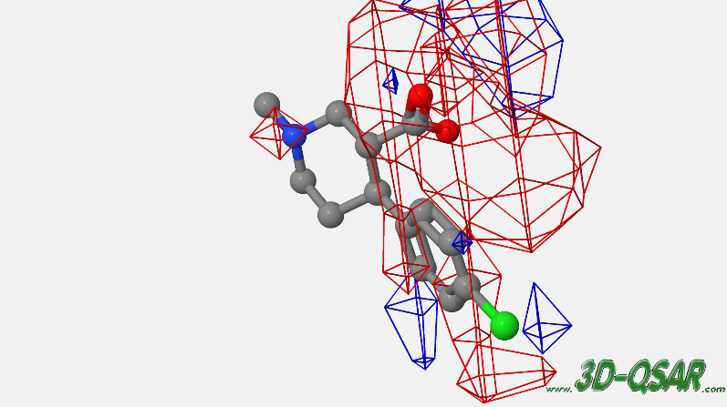
Figure 9: Electrostatic activity contribution contour map for moleucle 1a.
In the above diagram, we can see a large area of red contour around the -COOH structure, and fluorine atoms for electrostatic contribution in molecule 1a. This is because they have high electron density in that region that cause repulsive interaction.

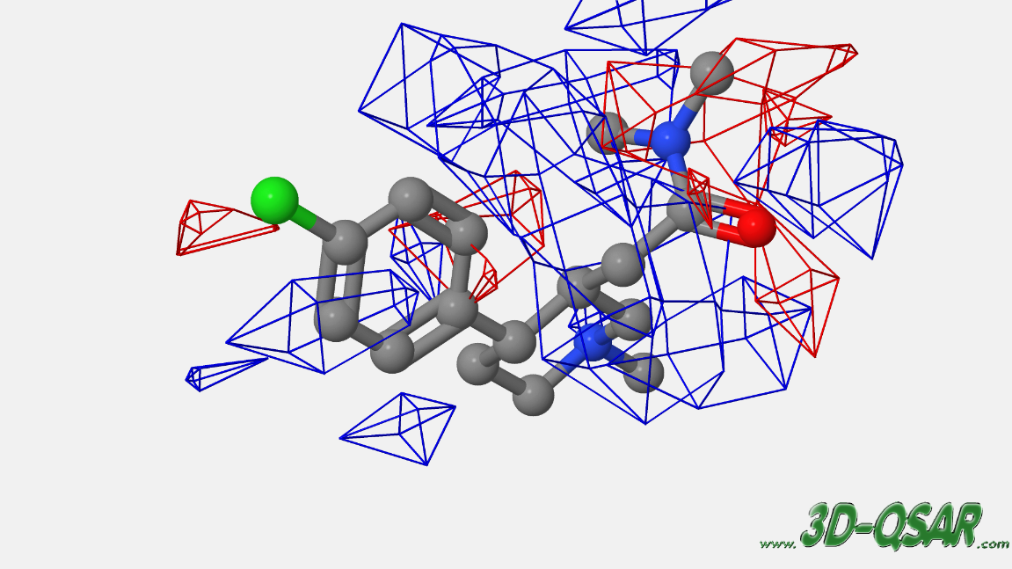
Figure 10: Electrostatic activity contribution contour map for moleucle 2g.
In the diagram above, most of the region of the molecule 2g has blue contour, but have red contour in the fluorine and oxygen and nitrogen atom. This is more matching to the steric contribution map, showing that this molecule has more specific region where the activity occur. The electrostatic contribution of this two molecules are very different.
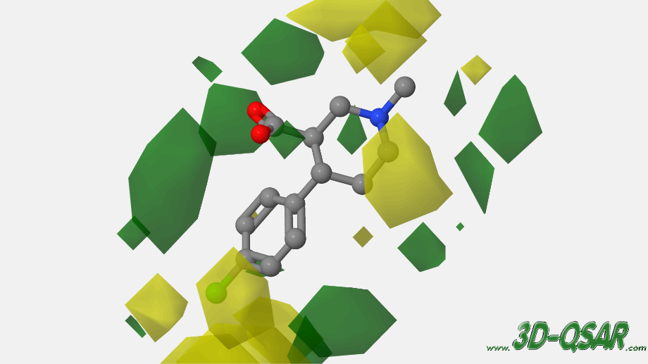
Figure 11: Steric activity contribution contour map of molecule 1a.
In the diagram above, we can see that the less potent of the molecule might because the small area of green steric favorable in around the molecule, and more area of yellow steric unfavorable area, compared to the contour map of 2g below.
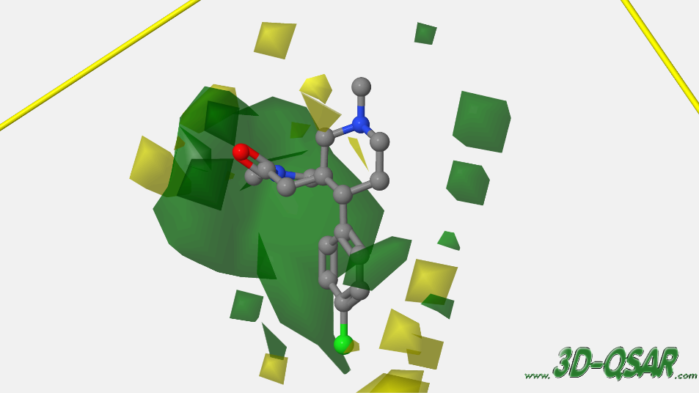
Figure 12: Steric activity contribution contour map of molecule 2g.
As we can see that the contour map for the two molecules are very different, showing that the most active part is the nitrogen structure with oxygen nearby, which cause them donating electron pairs, and has large area of green contour. Comparing to molecule 1a, the COOH structure does not contribute as much as the structure in 2g molecule. The steric activity map for molecule 2g has very large green area compare to molecule 1a, chowing that the high activity of compounds. This might also because the ring structure presence as the bulk that reduce the potency of compound in molecule 1a.

Conclusions
We have constructed highly predictive and statistically significant CoMFA models for the DAT dataset. The statistical results improved when we find the right parameters to make the model, which is perform VPO with Y-scrambling and external test set. We have seen that the contour map for different potency of molecules behaved very differently. CoMFA models suggest us that the steric and electrostatic interactions, play important roles in the binding of the molecules. These findings will guide us for the design and improve the compounds with DAT activity.

References
- Teaching and Learning Computational Drug Design: Student Investigations of 3D Quantitative Structure–Activity Relationships through Web Applications.Rino Ragno, Valeria Esposito, Martina Di Mario, Stefano Masiello, Marco Viscovo, and Richard D. Cramer.Journal of Chemical Education 2020 97 (7), 1922-1930.DOI: 10.1021/acs.jchemed.0c00117
- Yuan H, Kozikowski AP, Petukhov PA. CoMFA study of piperidine analogues of cocaine at the dopamine transporter: exploring the binding mode of the 3 alpha-substituent of the piperidine ring using pharmacophore-based flexible alignment. J Med Chem. 2004 Dec 2;47(25):6137-43. doi: 10.1021/jm049544s. PMID: 15566285.
- Ragno R. www.3d-qsar.com: a web portal that brings 3-D QSAR to all electronic devices-the Py-CoMFA web application as tool to build models from pre-aligned datasets. J Comput Aided Mol Des. 2019 Sep;33(9):855-864. doi: 10.1007/s10822-019-00231-x. Epub 2019 Oct 8. PMID: 31595406.

